DESIGN TABLES FOR PRODUCT AND CATEGORY ENTITIES.
Project Title: Seller and Inventory Management System

Project Title : Seller and Inventory Management System
Student Name : Tamil raj M
Register Number : C4S38022
Department : B.Sc Artificial Intelligence
Course : Artificial intelligence (AI)
Academic Year : 2024 – 2027

1: Create Database
CREATE DATABASE SellerDB;
2: Create Seller Table
CREATE TABLE Seller (
SellerID INT PRIMARY KEY,
SellerName VARCHAR(50),
Phone VARCHAR(15)
);
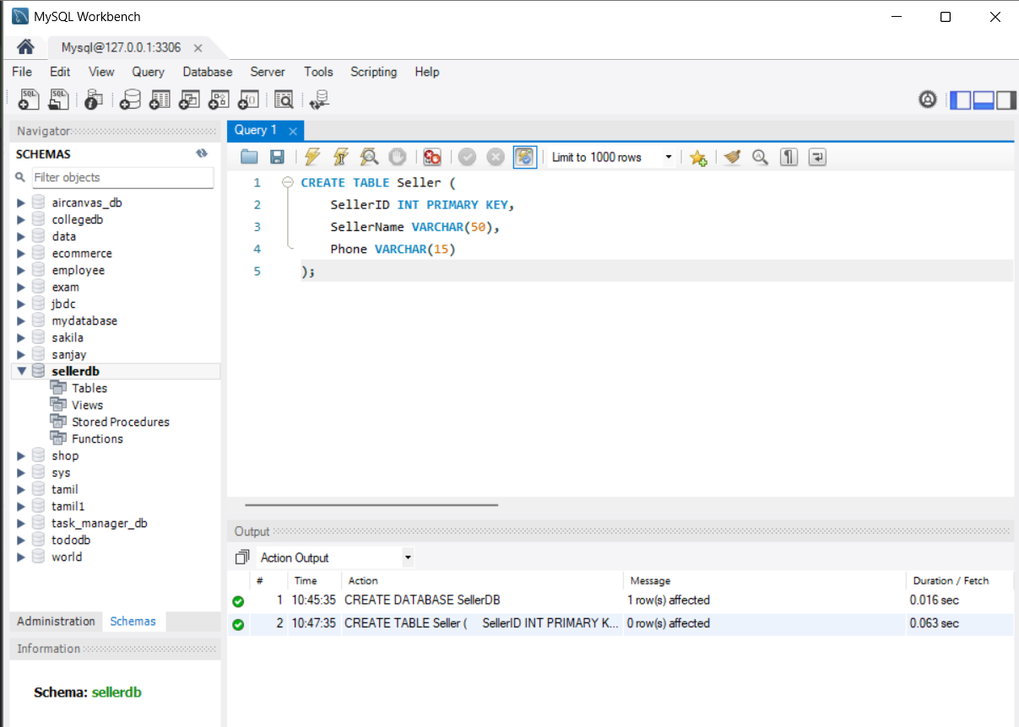

3: Create Product Table
CREATE TABLE Product (
ProductID INT PRIMARY KEY,
ProductName VARCHAR(50),
Price DECIMAL(10,2)
);
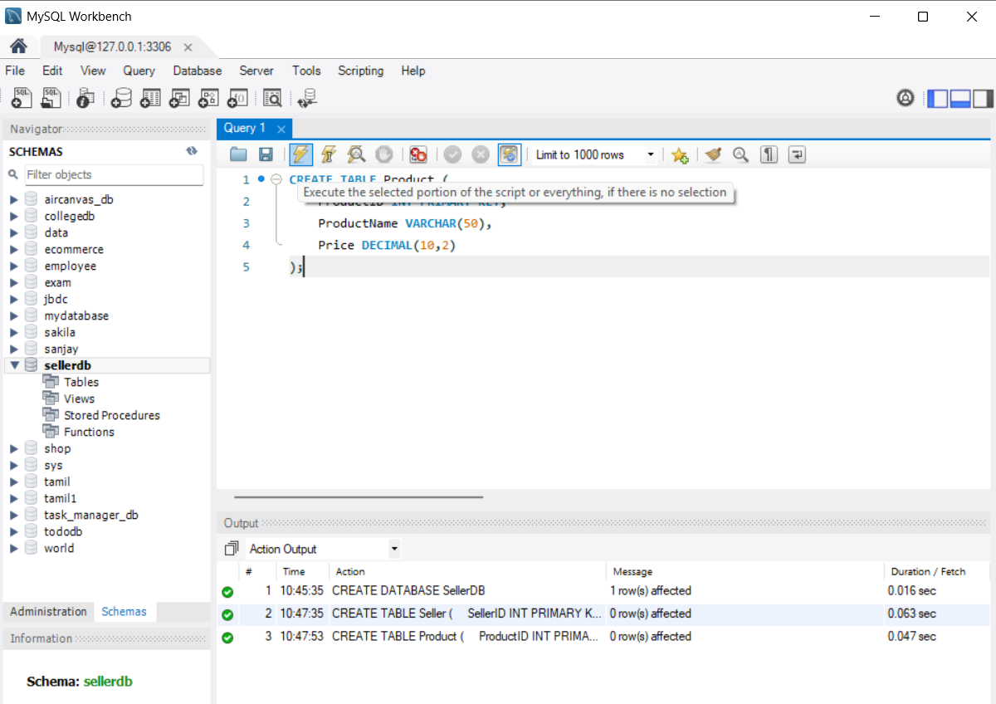

4: Create Inventory Table
CREATE TABLE Inventory (
InventoryID INT PRIMARY KEY,
SellerID INT,
ProductID INT,
Stock INT,
FOREIGN KEY (SellerID) REFERENCES Seller(SellerID),
FOREIGN KEY (ProductID) REFERENCES Product(ProductID)
);
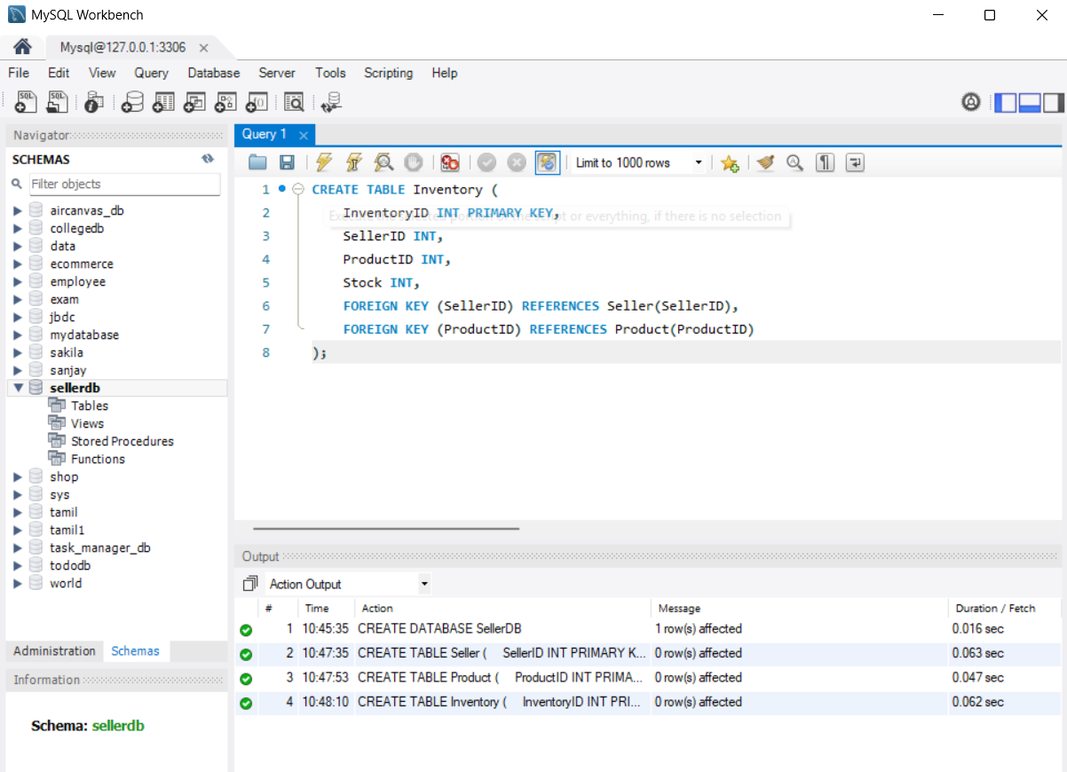

5: Insert Sellers
INSERT INTO Seller VALUES
(1, 'Ravi', '9876543210'),
(2, 'Kumar', '9876501234'),
(3, 'Arun', '9876512345');
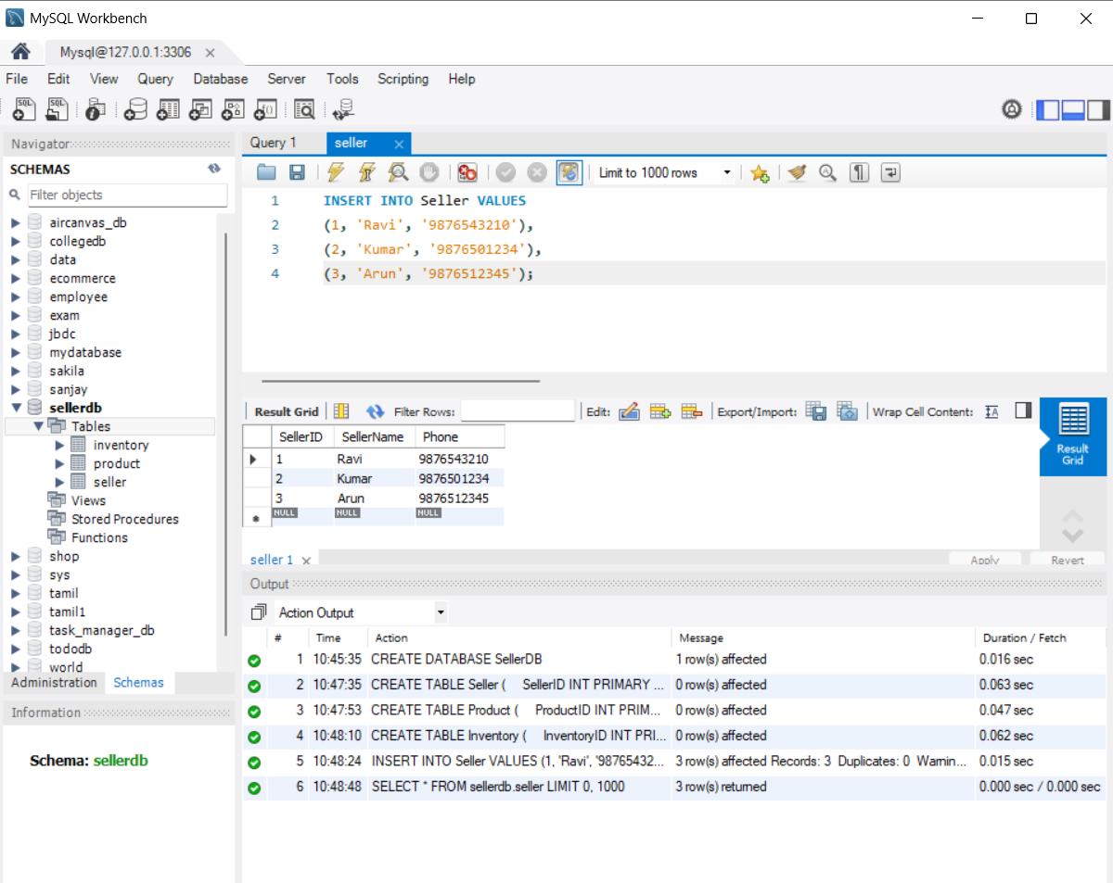

6: Insert Products
INSERT INTO Product VALUES
(101, 'Laptop', 60000),
(102, 'Mobile', 25000),
(103, 'Headphones', 2000),
(104, 'Keyboard', 1000);
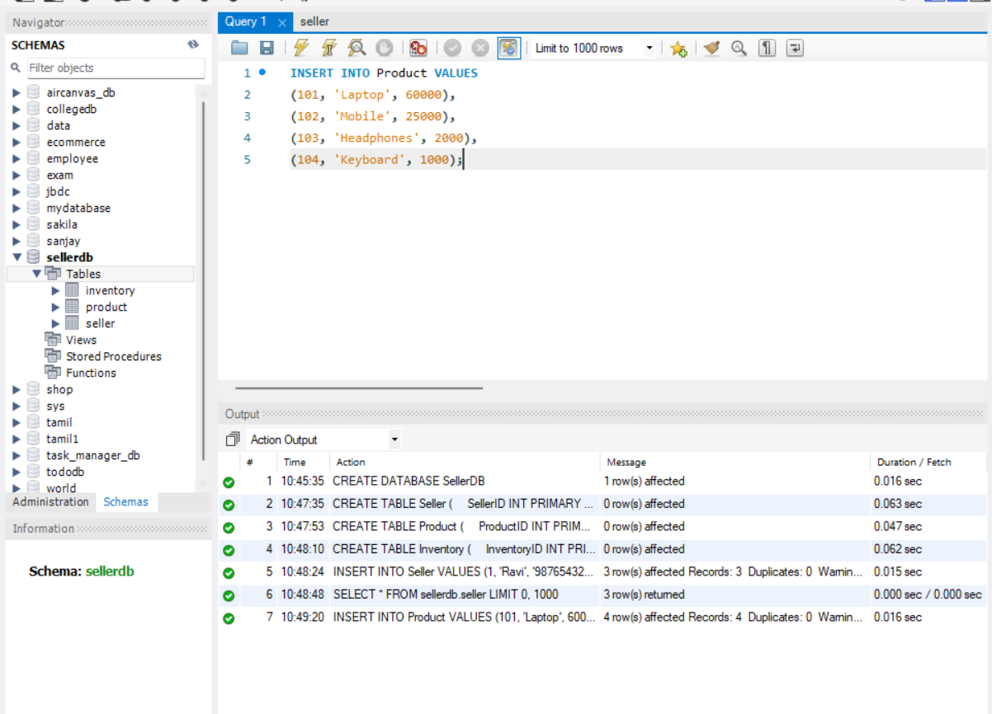

7: Insert Inventory
INSERT INTO Inventory VALUES
(1, 1, 101, 10),
(2, 1, 102, 0),
(3, 2, 103, 25),
(4, 3, 104, 0);
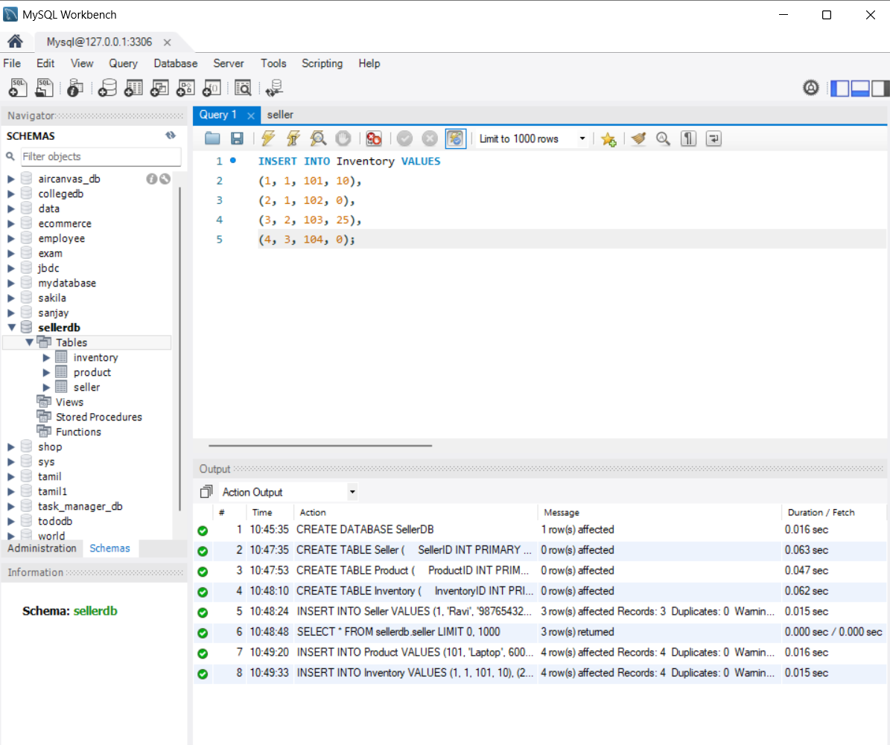

Step 8: Find Available Products
SELECT
Product.ProductName,
Inventory.Stock
FROM Product
JOIN Inventory
ON Product.ProductID = Inventory.ProductID
WHERE Inventory.Stock > 0;
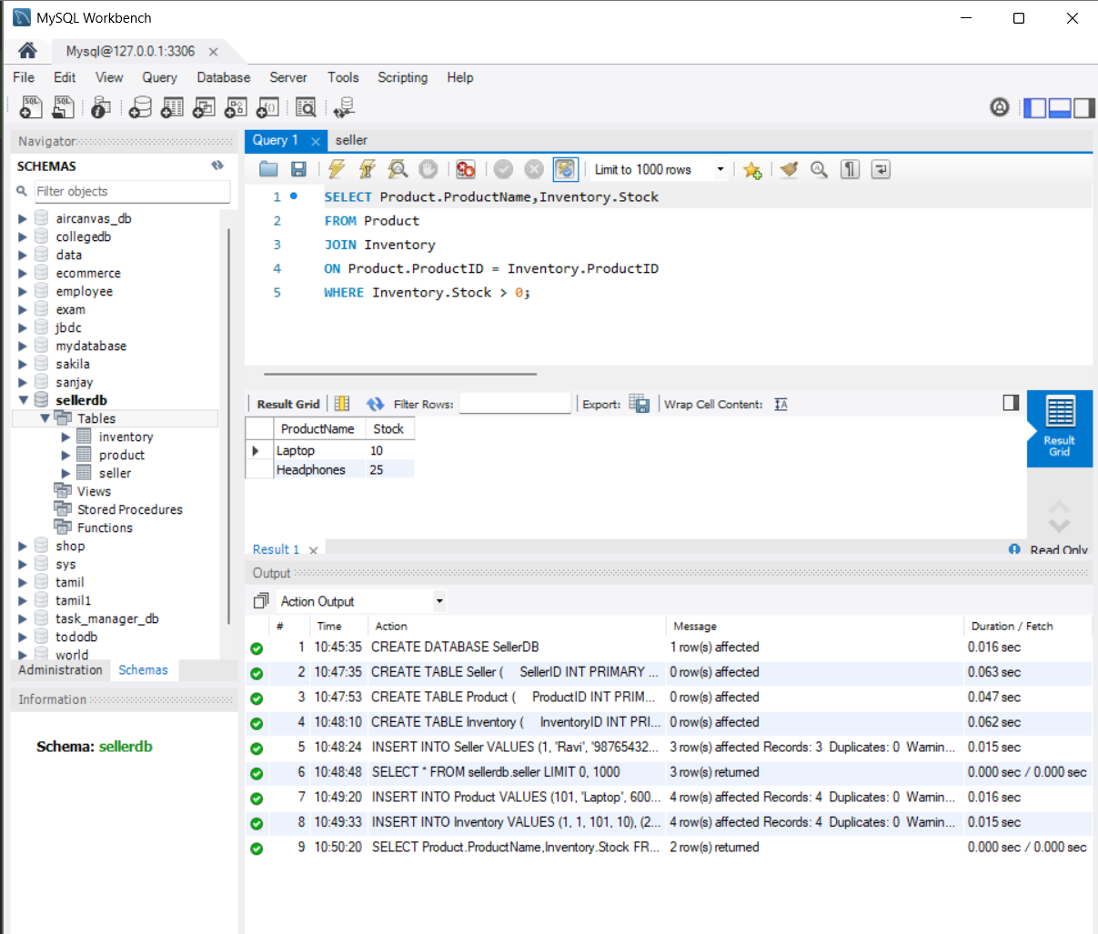

9: Inventory Status Report
SELECT
Product.ProductName,
Seller.SellerName,
Inventory.Stock,
CASE
WHEN Inventory.Stock > 0 THEN 'Available'
ELSE 'Unavailable'
END AS Status
FROM Inventory
JOIN Product
ON Inventory.ProductID = Product.ProductID
JOIN Seller
ON Inventory.SellerID = Seller.SellerID;

